Three Point Lighting
Beringson – AV tech &Film 1
The Three Point Lighting Technique is a standard method used in visual media such as video, film, still photography and computer-generated imagery. It is a simple but versatile system which forms the basis of most lighting. Once you understand three point lighting you are well on the way to understanding all lighting.
The technique uses three lights called the key light, fill light and back light. Naturally you will need three lights to utilize the technique fully, but the principles are still important even if you only use one or two lights. As a rule:
- If you only have one light, it becomes the key.
- If you have 2 lights, one is the key and the other is either the fill or the backlight.

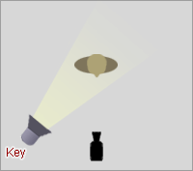

Key Light
This is the main light. It is usually the strongest and has the most influence on the look of the scene. It is placed to one side of the camera/subject so that this side is well lit and the other side has some shadow.

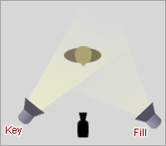

Fill Light
This is the secondary light and is placed on the opposite side of the key light. It is used to fill the shadows created by the key. The fill will usually be softer and less bright than the key. To acheive this, you could move the light further away or use some spun. You might also want to set the fill light to more of a flood than the key.
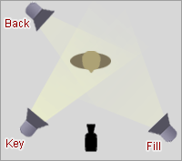

Back Light
The back light is placed behind the subject and lights it from the rear. Rather than providing direct lighting (like the key and fill), its purpose is to provide definition and subtle highlights around the subject's outlines. This helps separate the subject from the background and provide a three-dimensional look.
If you have a fourth light, you could use it to light the background of the entire scene.

Directions:
With your group, use the lights to set up a three point lighting model with a camera on one person from your group acting as the subject
-Try to create a clean look by turning on your lights and adjusting each of them (and the subject) so that they achieve their individual purpose.
-Once you have it set up so it looks good, go ahead and turn them all off. Have members form your group stand at each light one one to operate the camera. The camera will not move.
-Make sure you have the HDMI cable form the TV plugged into the camera.
-Turn each light on in sequence…First the Key light, wait 5 seconds.
-Turn on the fill light next, wait 5 seconds.
-Lastly, turn on the fill light and hold the shot for at least 5 seconds.
-Take the footage and do a simple edit by adding text that says “key light,” “fill light,” etc…
-Feel free to add music if you want.
-Add to your Weebly page (no story board, script, or journal needed)…short description of video only.

